THESIS TITLE: HEART RATE MONITORING THROUGH PHOTOPLETHYSMOGRAPHY

A THESIS SUBMITTED TO
THE FACULTY OF ACHITECTURE AND ENGINEERING
OF
EPOKA UNIVERSITY

BY

ALESIA GARULI

IN PARTIAL FULFILLMENT OF THE REQUIREMENTS
FOR BACHELOR DEGREE
IN ELECTRONICS AND DIGITAL COMUNICATION ENGINEERING

MONTH (JUNE), Year (2022)

I hereby declare that all information in this document has been obtained and presented in accordance with academic rules and ethical conduct. I also declare that, as required by these rules and conduct, I have fully cited and referenced all material and results that are not original to this work.

Name, Last name: Alesia Garuli

Signature:

ABSTRACT

HEART RATE MONITORING THROUGH PHOTOPLETHYSMOGRAPHY

Garuli, Alesia
B.Sc., Department of Computer Engineering
Supervisor: Prof. Dr. M. Maaruf Ali

Electronics have a lot of applications in different fields, and one of the most important applications that has been evolving rapidly during the past decades has been electronics in the field of medicine and healthcare. One of the electronic sensors that has been high in demand in the past few years are photoplethysmographic sensors, which offer a lot of applications. Operating on the concept of plethysmography, these electronic sensors are able to provide us with a lot of biometric data, such as heart rate, blood oxygen levels, respiration rate, etc. The monitoring of the heart and blood parameters can offer a lot of insight into one’s medical condition, and it can also help to diagnose various disorders or diseases. They have become so accessible and convenient, such that everyone might have an optical biometric sensor on their house, whether it is a small medical device that can wrapped around your finger or the sensor on a smartwatch. Especially during COVID-19, PPG sensors have been even more demanded, since it was an era when everyone was extra wary of their health. With this thesis, I wanted to review the different applications and methods of plethysmographic sensors, and also try to fabricate a simple and affordable heart rate reader using a pulse sensor and a microcontroller.

Keywords: photoplethysmography, heart rate, motion noise, pulse sensor, microcontroller;

Table of Contents
1 INTRODUCTION 1
1.1 Motivation for thesis 1
1.2 Thesis Overview 1
1.3 Monitoring Heart Rate through Photoplethysmography 2
2 LITERATURE REVIEW 4
2.1 Evolution of photoplethysmography 4
2.2 Applications 5
2.3 The challenges of making an accurate pulse oximeter 7
2.4 Optomechanics 9
2.5 Signal Extraction Algorithms 11
2.6 Instrumentation 13
3 METHODOLOGY 14
3.1 Hardware Setup 14
3.2 Software 19
3.3 Detecting a heartbeat 20
3.4 Trying to calculate a numerical value of the heart rate 24
4 CONCLUIONS 26
REFERENCES 27
APPENDIX A 29
ARDUINO CODE WITH JUST AVERAGEING FILTER 29
APPENDIX B 31
ARDUINO CODE FOR THE FINAL WAVEFORM 31

List of figures
Figure 1.1 How PPG works 2
Figure 2.1 Evolution of PPG 5
Figure 2.2 (a) Transmission mode (b) Reflection mode 11
Figure 2.3 Instrumentation 13
Figure 3.1 Reflection mode sensor 14
Figure 3.2 Pulse sensor 15
Figure 3.3 Structure of pulse sensor 16
Figure 3.4 Arduino Microcontroller 17
Figure 3.6 Connection of the project 18
Figure 3.5 connection of the sensor to the arduino pins 18
Figure 3.7 Final Product 19
Figure 3.8 Raw signal 1 20
Figure 3.9 Raw signal 2 21
Figure 3.10 Signal after "averaging" filter (20 readings avg.) 22
Figure 3.11 Signal with an avg. of 10 readings 23
Figure 3.12 avg. of 30 readings. The rising curve indicates a heartbeat 23
Figure 3.13 Biometrics we can detect from PPG signals 24
Figure 3.14 Numerical values from the serial monitor 25
Figure 3.15 Final signal waveform 25

List of tables
Table 2.1 Summary of the algorithm methods used in PPG 12
Table 3.1 Arduino Microcontroller Components 17

INTRODUCTION

Motivation for thesis
There have been two main motivations behind this thesis.
Firstly, out of all the applications of electronics and telecommunication, I find its application in medicine and healthcare the most interesting to work with. Combining the knowledge about the human body and technology of signal processing is a very intriguing research idea.
Secondly, I choose such a topic because of how important health awareness is. During the hard time of the coronavirus, a lot of people have become way more conscious about monitoring their health. The convenience of PPG sensors is that they can be made into compact wearable devices, so that they can be accessible by anyone.

Thesis Overview
The main thing to be taken out of this thesis is how simple sensors can produce a complex output operating through the concept of plethysmography. The main topics to be reviewed are:
- How PPG works and what it can be used for
- Challenges of PPG
- What to consider when manufacturing a PPG device
- How to construct a simple Arduino Pulse Sensor and produce a simple heart rate curve without needing to utilize complex filters

Monitoring Heart Rate through Photoplethysmography
Out of the many ways to monitor one’s physiological condition of the heart, a method that has become very popular and increasingly demanded nowadays is the use of optical sensors.
Optical heart sensors, mostly known as pulse oximeters, employ the method of photoplethysmography in order to acquire the heart rate signal. These devices have a plethora of applications, and they are most commonly known for measuring oxygen blood levels.
Photoplethysmography (PPG) is a simple and low-cost technique that uses infrared light to evaluate the blood-flow near the surface of the skin to record waveforms and measure blood pressure or other parameters. The PPG cast light on the wearer’s skin through light emitting diodes and acquire the reflected or transmitted light whose intensity depends on the volume of blood existing in the arteries under the skin. PPG depends on the changes in the blood volume in these blood vessels which modify the reflection, absorption, and scattering of the light. Through these changes we are able to get a signal and measure heart rate and cardiac output respectively. For PPG sensors to be able to function according to this concept, their two key components are usually a LED light and a photo detector.
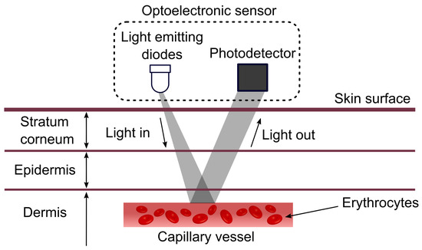
Figure 1.1 How PPG works
Since PPG is a non-invasive method which utilizes infrared light to measure blood flow at skin surface, it is very convenient to be made into wearable devices. Skin-interfaced wearable devices provide the advantage of monitoring health parameters at any given time in a comfortable manner and their demand has been increasing more and more during the past decade.

LITERATURE REVIEW

Evolution of photoplethysmography
Normally, one would think that the concept behind PPG techniques is a modern notion that has only surfaced recently. Well, that is not quite the case. Optical blood flow monitoring is actually a technique that dates back in the 1800s. People would hold up their hand near a lit candle in a dark room and observe the vascular structure and blood flow through the thinner skin of the hands. This concept has been continuously evolving through the past two centuries in order to become the technology that we use today in medicine and everyday life.
In the early 1900s, Matthes developed the first oxygen saturation meter, which utilized a 2-wavelength light source with red and green filters. One of the main issues with this device was its difficult calibration. Then in the late 1930s, a self-calibrating oximeter was introduced by Squire. Millikan, a British scientist, invented the first aviation ear oximeter in the 1940s, which was utilized in pilot training during World War II. Wood modified the device a few years later at Mayo Clinic by adding an inflated balloon to block blood flow during calibration. Hewlett Packard employed eight wavelengths of light to improve the oximeter in 1964, but it was mostly used in sleep laboratories due to its size and cost. Then, in 1972, Japanese engineer Takuo Aoyagi's major achievement made oximetry clinically feasible. His version of the pulse oximeter would measure the pulse and blood oxygen using the ratio of red to infrared light absorption in the blood, which is very similar to the method pulse oximeters employ nowadays.

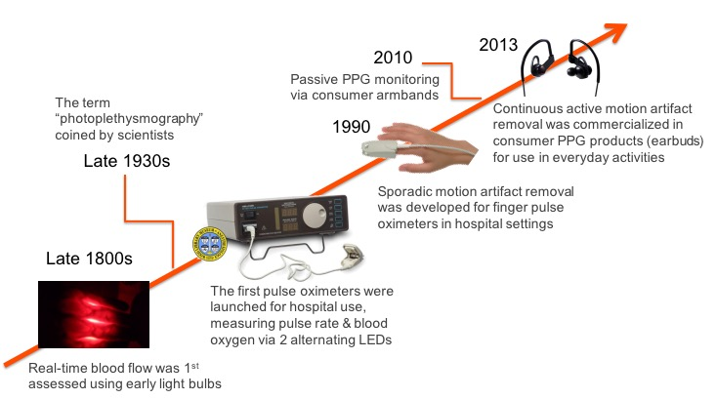
Figure 2.1 Evolution of PPG

Applications
As we’ve seen so far, optical health monitoring sensors are high in demand and have become increasingly popular during the past years. Thanks to the evolution of PPG methods, they actually have quite a wide range of application. Pulse oximeters were originally used in the operating room by anesthesiologists to observe unconscious patients. After that, the technology was approved for usage in the intensive care unit (ICU) and vital sign checking. Nowadays, the PPG signal is practically used in clinical oximeters for oxygen saturation and pulse rate measurement in primary clinics and as a fitness indicator in smartwatches.
In our methodological approach we will simply be utilizing this method to implement a simple heart rate monitoring device using the analogue output of the optical sensor, but more complex, accurate, motion-tolerant PPG sensors can be used to measure a large variety of health parameters. Here are some of them:
Pulse Rate (PR) and Its Variability (PRV)
Pulse rate and pulse rate variability are the vital signs that are essential evidence of a patient’s health and very useful for diagnosis, monitoring, and/or screening of different diseases.
Blood Oxygen Saturation
Blood oxygen saturation (also called oxygen levels) indicates the concentration of oxygen in the blood. Measuring patient blood oxygen levels using a finger sensor is a very common practice in inpatient monitoring or outpatient checkup. When a patient has poor blood circulation in the fingers, an Ear Pulse Oximeter with an ear probe can be used on the earlobe.
Blood Pressure (BP)
Blood pressure (BP) evaluation is an essential measure in clinical practice. A patient’s BP is routinely obtained at every physical examination, including outpatient visits and inpatient monitoring. Many researchers evaluate the estimation of BP using PPG signal only, while others paired it with other types of signals, such as ECG and BCG.
Respiration Rate (RR)
R-R interval is the time between blood pulses, and the general rule says that the more varied the time between beats, the better. R-R interval analysis can be utilized as an indicator of stress levels and a variety of cardiac issues, for instance, arrhythmia.
Cardiac efficiency
Cardiac efficiency is another indicator of fitness that typically measures how efficiently your heart works to take one step. This serves as a proxy for how hard your heart would have to work to do more challenging exercises like running or cycling, which is usually measured in wearable PPG devices.

Listed above are the most common applications of PPG, which are probably health parameters everyone has heard of. Some lesser known clinical application of PPG in medicine that might be worth mentioning are: Jugular Venous Pulse (JVP), Ankle Brachial Index (ABI) and microcirculatory blood flow.
These are all parameters and health indicators that can be calculated through specific algorithms, however PPG applications are not limited to just those. By analyzing the PPG signal waveform and other outputs, medics can understand a lot about someone’s health. Based on PPG signals they can diagnose: cardiovascular diseases, sleep disorders, diabetes and also an individual’s psychiatry (for instance their stress levels or if they have anxiety).
Furthermore, PPG methods can also be utilized to monitor patients in different scenarios, such as: patients in OPD (outpatient department), during surgery, during COVID-19 and during dialysis.

The challenges of making an accurate pulse oximeter
While PPG is quite convenient, it can be very easy to make a bad PPG device, especially if we intend for this device to be wearable throughout the day (it is harder because it would have to be motion-tolerant).
Here are some of the most common issues engineers might face when trying to make a PPG health-monitoring device:
Optical noise – The biggest technical issue we face as engineers when processing the signal from the sensor is separating the biometric signal from the noise, especially motion noise. Unfortunately, when you shine light into a person’s skin only a small fraction of the light is reflected back (or transmitted) to the sensor, and out of that total light collected, only about 1/100th of it may actually indicate heart-pumped blood flow. The rest of the signals are simply scattered by other material, such as skin, muscle, tendons, etc.
Skin tone - Humans have a diverse range of skin tones, with different levels of melanin, and the level of melanin in someone’s skin affects how it absorbs light. For example, darker skin absorbs more light, which presents a problem because many pulse oximeters don’t use the right mitigations to accurately measure heart rate through dark skin. Fortunately, optical sensors can actually be designed in a way to be melanin-friendly, as long as we are sensible to take this issue into consideration.
Crossover problem – One of the most challenging aspects of optical noise for PPG devices is the noise created during motion and physical activities. This is most often seen in the step rates measured during jogging and running because step rates typically fall into the same general range as that of heartbeats. The problem that many devices have to face is that the algorithm (which processes optical sensor data) might easily mistake the step rate for heart rate. This is known as the “crossover problem”, because if you look at the measurements on a graph when the heart rate and step rate crossover each other, many devices tend to lock on to step rate and acknowledge that number as the heart rate, even though the heart rate might be changing drastically after the crossover. Since the methodological approach of this thesis will implement an immobile device, we won’t have to face this issue, however since wearable sensors are the most demanded it is good to take notice of this issue.
Sensor location- The location of the pulse oximeter is one of the key problems engineers should take into account. Not every part of the human body is suitable for using an optical sensor on. We need to take into account: the density of blood vessels near the skin surface, thickness of the skin, optical noise created by muscle, bone or tendons and other factors. Most modern wearable sensors are worn on the wrist, but ironically enough, turns out the wrist is actually one of the worst spots for accurate PPG heart rate monitoring. The wrist area is filled with tendons and ligaments that scatter light, and it is more susceptible to motion noise. One of the best places to measure biometrics is actually the ear, because it is the location least susceptible to motion noise, however, it is not suitable for long term wear or continuous monitoring. For this thesis, we will be monitoring heart rate from the fingertip, and try to filter out the motion noise.
Low perfusion- Perfusion is the process of our body delivering blood to capillary beds. The level of blood perfusion can vary a lot across different population, which raises a similar problem to the one with skin tone. obesity, diabetes, heart conditions, and arterial diseases are all factors that affect blood perfusion, probably lowering it and making it more difficult for us to accurately monitor heart rate through PPG methods. The signal-to-noise ratio may be drastically decreased, as lower perfusion means lower blood flow signals. This is actually another reason why the ears are the best location for accurate PPG monitoring, because the head area supports much higher blood perfusion, unlike the wrists and fingertips.

Optomechanics
After we have reviewed some challenges one might face in the making of a good PPG device, we can now take a look at the key methods utilized to make our device as accurate as possible.
So if we were to develop an accurate and effective PPG device, there are two sides of this project we need to consider: good optomechanics (the hardware side of the project) and a good signal extraction algorithm (the software side).
One might think that good optomechanics may also depend on the budget you have for making a PPG device. While that is very true, most pulse oximeters are pretty affordable and good optomechanics is also greatly dependent on a lot of technicalities. Here are some questions we should ask ourselves when making an optical heart rate monitoring device:
Is light guided effectively to the skin surface of the body?
When asking ourselves such a question, we should take notice of the various environmental noises that might affect the signal… such as sunlight which would add more background noise to the reading.
Are the wavelengths we are using compatible with the location we have chosen for the sensor?
The physiological structure of the body differs throughout it, which means that the same wavelength won’t work for different locations. Like for instance, the wavelength used for monitoring heart rate with an ear sensor is different from the wavelength we would use if we were to put the sensor on the wrists.
How many light emitters are we using? Is the spacing correct?
Correct spacing will provide us with a “cleaner” signal (less motion noise).
Speaking of optomechanics, let’s take a look at the general structures of PPG sensors, and each one might be more suitable for a different application.
Based on the placement of the LED and the photo detector, there are two methods by which the PPG sensor can operate. They are called (a) transmission mode and (b) reflection mode.
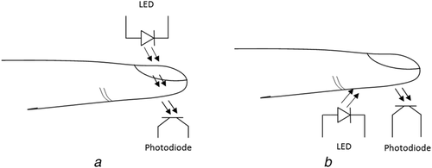
Figure 2.2 (a) Transmission mode (b) Reflection mode
The LED and PHD (photodetector) are located on opposite sides of the measured human tissue (in this case the finger) in the transmission mode measurement. The PHD detects a leftover light from the source after it has been absorbed by the tissue in this case. In reality, a wearable PPG sensor of this sort is commonly implemented as a finger ring (FR), a finger clip (FC), or an ear clip (EC). The finger kinds are commonly employed in medical applications (FC for pulse oximeters), while the EC realization is frequently used for vitality monitoring.
The IF/RD LEDs and the PHD measuring the intensity of the reflected light are arranged side by side on the same body surface in PPG sensors that work on the reflection principle. As a result, reflection sensors provide greater flexibility in measuring PPG signals from various locations on the body, making them more suitable for non-invasive portable long-term monitoring devices.
Getting the optomechanics of the device correctly is essential in order to provide a good signal input.

Signal Extraction Algorithms
When processing the output, we should take into consideration the following questions regarding the signal extraction algorithm:
Are these algorithms valid on diverse populations?
It’s essential that the algorithms work well on different skin tones, genders, ages and body types.
Are these algorithms robust to multiple types of motion noise?
As we’ve mentioned the issue of motion noise countless times throughout this thesis, it is no wonder that this is a very important requirement.
Is this signal extraction method scalable to multiple form factors?
You wouldn’t want to use different algorithms for each different form factor you may want to use.
Are the algorithms continually improving to handle more use cases and new biometrics?
This technology is advancing very fast so it is necessary for the algorithms to be constantly updated.
There are different types of algorithms used for PPG sensor readings nowadays. For the analysis and understanding of the variables obtained through the measurement of Heart Rate Variability, some methods can be used, such as linear and nonlinear methods. Linear methods are divided into two types: time domain analysis, performed by using statistical and geometric indices, and frequency domain analysis. The parameters extracted from the measurement of the PPG signal both in the time domain as the frequency domain can provide valuable information about the control of the cardiovascular system
Table 2.1 Summary of the algorithm methods used in PPG
Method | Domain | Evaluated Indices
Linear | Time Domain | Statistical indices: SDNN, SDANN, SDNN_{i}, rMSSD, pNN50.
Linear | Time Domain | Geometric Indices: RRtri, TINN and plot of Poincare.
Linear | Frequency Domain | HF, LF and VLF
Non-linear | - | Correlation function, hurst exponent, fractal dimension

Instrumentation
For the acquisition of the PPG signal and the biometric information, it is necessary to collect the signal from the body of the person for prolonged periods. This is why it is important to condition the photoplethysmographic signal to instrumentation circuits in order to avoid the noise caused from movement as much as possible. The PPG signal presents low amplitudes, and therefore, noise heavily affects the quality and reading of the signal parameters, which means the signal is easily affected by various noises, such as the environment, breathing or movement. This is why PPG instrumentation is necessary.
As shown in the previous sections, the PPG sensor consists simply of an infrared light emitting LED and a light receiver phototransistor. Still, for the analysis of this signal it is also necessary to make use of filtering and amplification circuits. Here’s a general idea of what PPG instrumentation would look like:
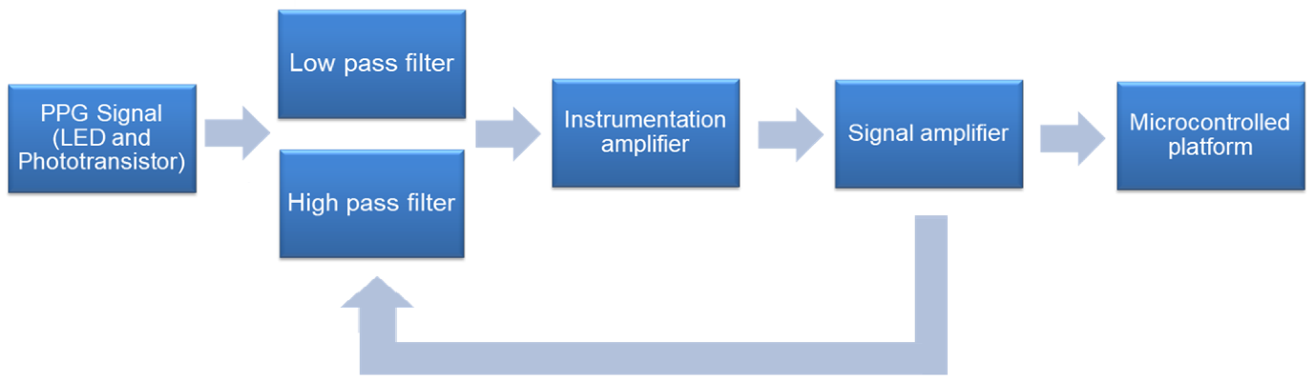
Figure 2.3 Instrumentation

METHODOLOGY

Hardware Setup
For the realization of this project I will be using Arduino Uno microcontroller and Arduino IDE software. The heart rate signal will be measured by a PPG sensor for Arduino microcontrollers, the pulse sensor.
As it has been mentioned earlier, there are two methods for PPG signal measurement: transmission mode and reflection mode.
The pulse sensor I have chosen operates according to the reflection mode.
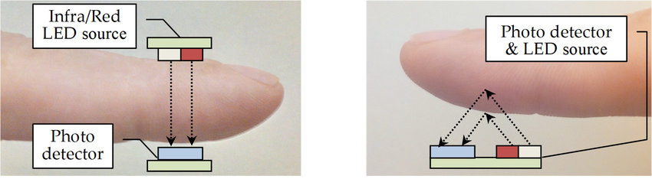
Figure 3.1 Reflection mode sensor
The LEDs and the PHD (photodetector) measuring the intensity of the reflected light are placed side by side on the same body surface. Due to this placement of the LEDs and PHD, these type of PPG sensors are more flexible, as they can be easily worn on different locations of the body.
The materials were ordered on “Desert Cart Albania”, and their information goes as follows:
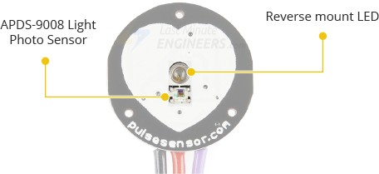
Figure 3.2 Pulse sensor
Pulse Sensor
Like it has been mentioned earlier, the two main components that make the pulse sensor work are the LED and the photo detector. Actually, photo detectors similar to the APDS-9008 are used in mobile phones, tablets and laptops in order to adjust the brightness of the screen in accordance with the light coming from the environment.
Output of the sensor: Analogue Signal. This works good for us because we want an analogue input. The Arduino microcontroller does make it possible for us to convert the signal to digital, but that wouldn’t be necessary, because we want a continuous signal in order to produce an accurate waveform of the heartbeat.
A low-pass filter and an amplifier composed of op amp are used to amplify signal by 330 times.
The sensor has a width of 16 mm.
“S”: Pulse analog signal output, connected to AD; (we will be connecting it to port A0)
“+”: Power input, 3.3V/5V; (we will be connecting it to port 5V)
“-“: GND;

The sensor is wearable on fingers and earlobes. We will be measuring the signal from the finger first, and then compare results. The finger is more susceptible to motion noise, however, since the pulse and wires are pretty delicate, it might be easier to keep the sensor worn on the fingertip.
As advised by the manufacturer, this sensor is appropriate for research and demonstration, however it can’t be used to provide actual medical information as it is very fragile and the input it provides needs a lot of work to be made into an accurate readable indicator of health.
Below there’s a figure provided by the manufacturer of the sensor, which shows its structure:
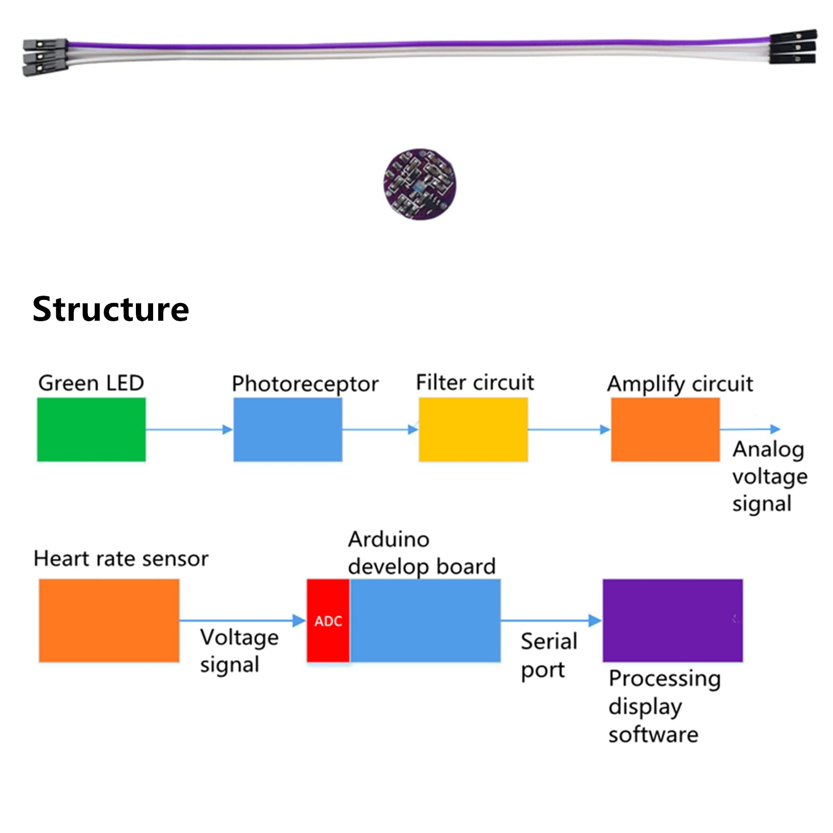
Figure 3.3 Structure of pulse sensor

Arduino Uno Board
The Arduino Board has 14 digital input/output pins (of which 6 can be used as PWM outputs), 6 analog inputs, a 16 MHz quartz crystal, a USB connection, a power jack, an ICSP header and a reset button.
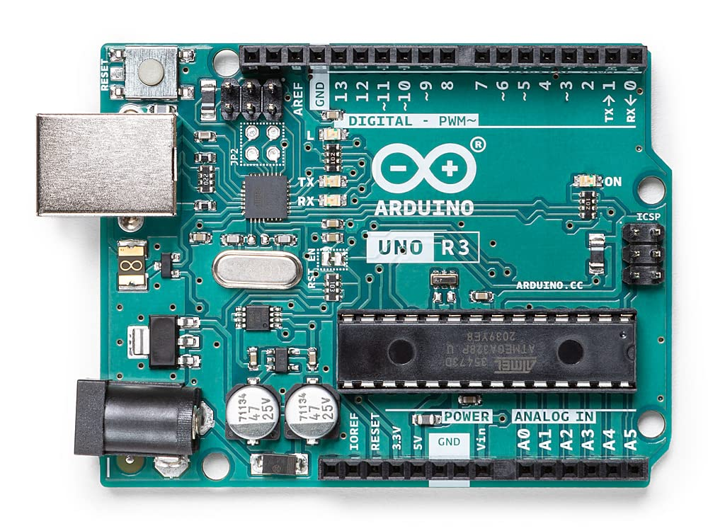
The board is easily connectable to any PC, and through the Arduino Software (IDE) we can upload our code into the microcontroller in order to process the signal from the pulse sensor.
Figure 3.4 Arduino Microcontroller
Table 3.1 Arduino Microcontroller Components
Microcontroller Microchip ATmega328P
Operating Voltage | 5V
USB | Standard Type B
Digital I/O Pins | 14 pins
PWM Digital I/O Pins | 6 pins
Analog Input Pins | 6 pins
Flash Memory | 32 KB
SRAM | 2 KB
EEPROM | 1 KB
Clock Speed | 16 MHz

The connection will be made as shown in the figure below. The pulse sensor will be connected through the Arduino pins using male-to-male jumper wires, and then the microcontroller will be connected to the laptop, from where I will upload the code into the microcontroller use the Arduino Integrated Development Environment (IDE).
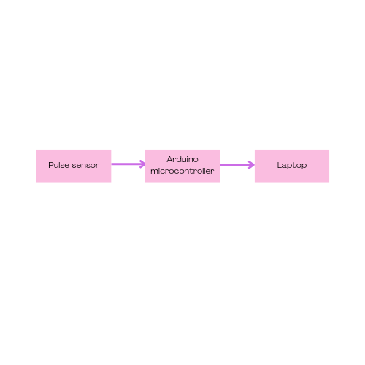
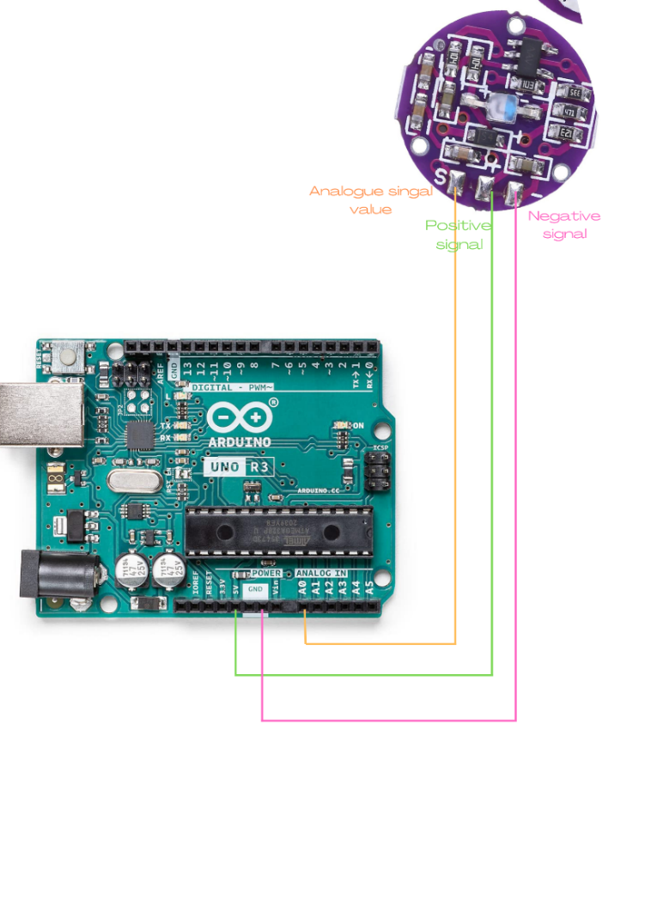
Figure 3.6 Connection of the project
Figure 3.5 connection of the sensor to the arduino pins
To connect the pulse sensor to the microcontroller is the trickier part. I will be using 3 jumper wires. They need to be male-to-male jumper wires, because we will need to connect the tip of the wire to the pulse sensor, and the other end of the wire will be inserted into the Arduino Analogue pins.

The connection will be:
“S” (Analogue signal value of the sensor) to “A0” (Arduino Pin);
“+” to “5V”;
“-“ to “GND”;
To connect the tip of the wires to the pulse sensor, I used a little bit of melted tin, as this is the most common way to connect circuits. Since I do not have a lot of experience in connecting hardware part, I tried to use a minimal amount of tin in order not to damage the sensor. However, this poses a little bit of a problem, because it is hard to keep the sensor still, and as it will be shown later a shaky sensor will affect the output I am trying to get.
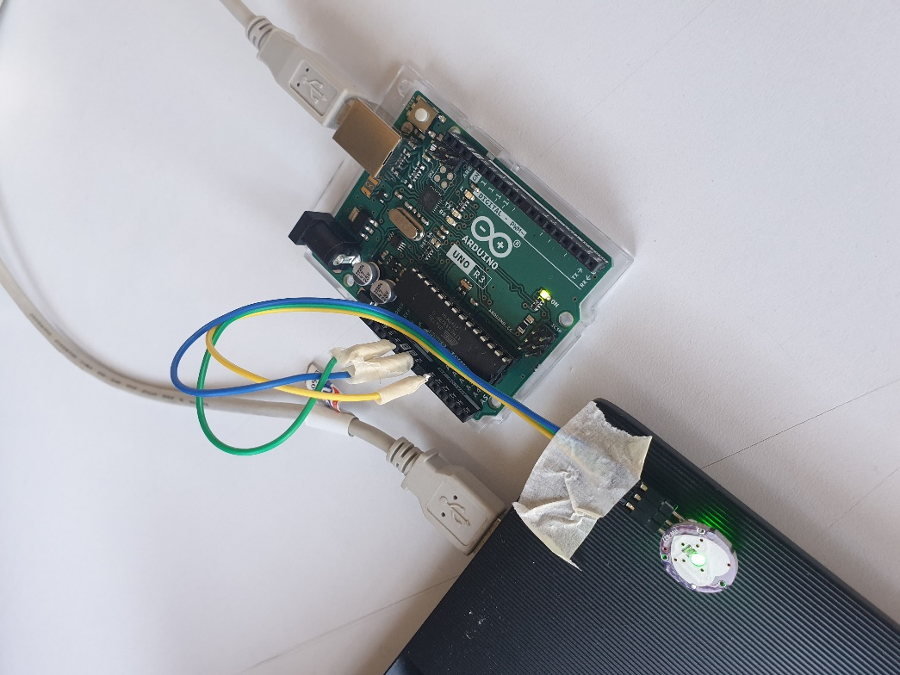
The final product ended up looking something like this:
Figure 3.7 Final Product

(Note: I placed the sensor like this purely for a better demonstration. I did not leave it stuck to the laptop because the heat might interfere with the pulse sensor.)

Software
When making a code to read and process the input from the pulse sensor, we also need to keep in mind that this code needs to be compatible with the type of signal we are getting and the Arduino Microcontroller. Consequently, I am going to use the Arduino Integrated Development Environment (IDE) to compile and upload the code into the microcontroller.
Later on we will be looking at different graphs in order to observe how the pulse sensor works, so for this part the Serial Plotter of the Arduino IDE will come in handy.
At the corner of the Serial Plotter, there is a selectable value that says “9600 baud”, which is the baud rate. The baud rate signifies the data rate in bits per second. In Arduino, the default baud rate used is 9600 bps (bits per second), which is also the baud rate I will be using for the code. I don’t think I will be going any higher than 9600 bps. While a higher baud rate signifies faster data transfer, there are obviously limits to how data can be transferred. A baud rate such as 115200 bps needs more bandwidth on the wire and is too fast for most microcontrollers.

Detecting a heartbeat
Firstly, a simple code which produces an output from whatever is read from the sensor will be tried out.
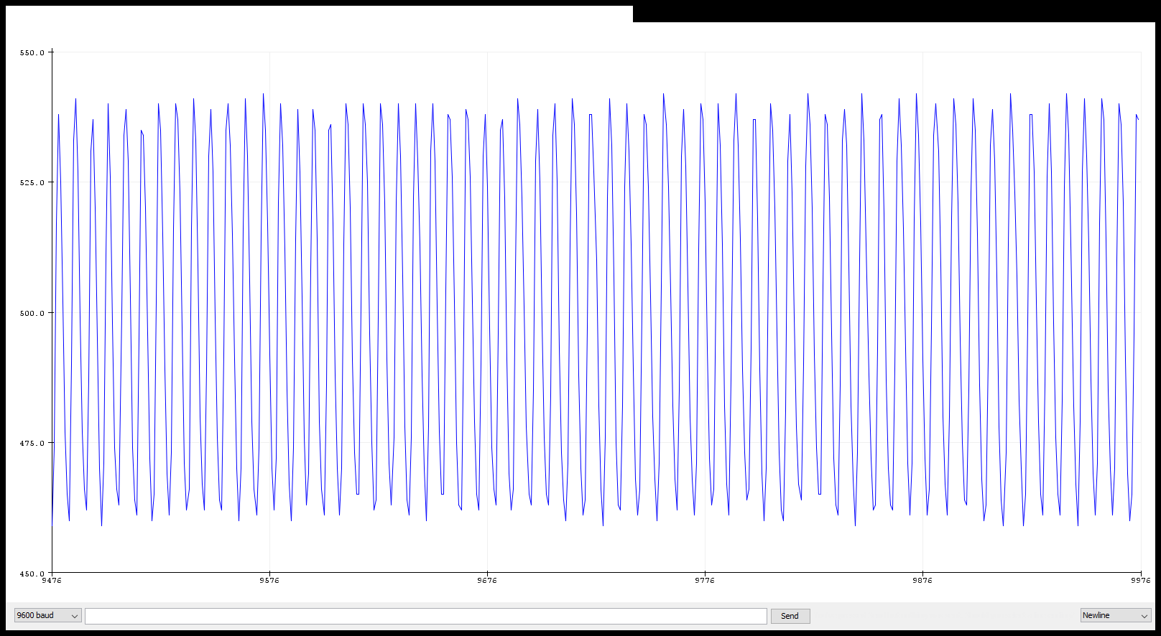
I will be using the serial plotter of Arduino IDE to produce a graph based on the signal that is being read.
Figure 3.8 Raw signal 1

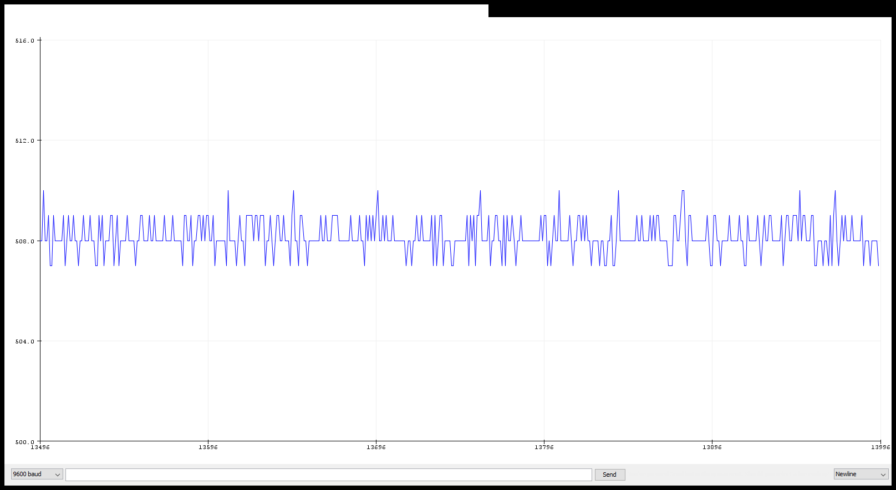
Looking at the two graphs we have here, the first one is what the sensor is reading when there is nothing on it (Figure 3.8) (so I have yet to put my fingertip on the sensor). The second graph is produced after I put my finger on the sensor (Figure 3.9). Obviously there is a great difference. While the second graph might remotely look like a heartbeat signal, it does not provide any actual accurate reading. If we look at it closely, the values are simply oscillating from 510 to 507. The reason the values are revolving around 500, is because that is the fixed value of the Arduino Serial Plotter, so this number does not indicate anything.
Figure 3.9 Raw signal 2
What the sensor is basically telling us how much is being reflected back at the sensor (hence the name reflection mode).
As stated in the MegunoLink website, which is a platform for a companion application of Arduino, two very common filtering algorithms in Arduino codes are averaging and running average.
Given that the various noises in the signal may disrupt the output, so taking an average might give us a more reasonable output. I will first be trying out to get an average of 20 readings (it wouldn’t be good to calculate the average of way too many readings because that would slow down the graph way too much).
So to get an output based on the 20 last readings, I will be creating an array to contain those readings. First, define a constant that tells the array the number of readings we want. Then create the array. We also need a sum variable in order to calculate the average. I want this array to be updated constantly for each new reading the sensor is getting. In order to achieve that, the oldest variable in the array will be replaced with the newest. To update the sum for each new reading, subtract the oldest reading from a sum and add the newest reading to the sum.
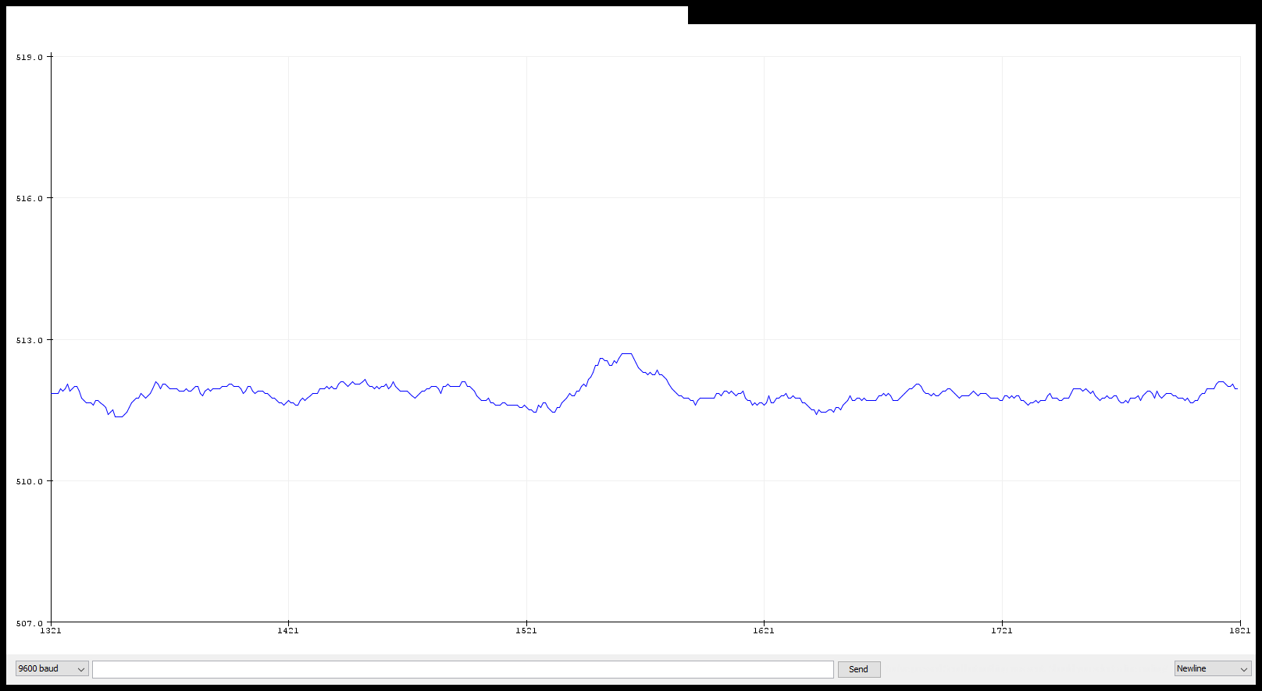
Figure 3.10 Signal after "averaging" filter (20 readings avg.)
Getting the average of 20 readings makes the serial plotter work a little slowly, which is inconvenient because the sensor is pretty fragile and I have to try to keep my finger very still in order for the graph to actually stabilize and be plotted. So I will try to cut that time in half by taking the average of 10 readings instead. The graph turned out like in figure. It seems to be much noisier and there are a lot of spikes.
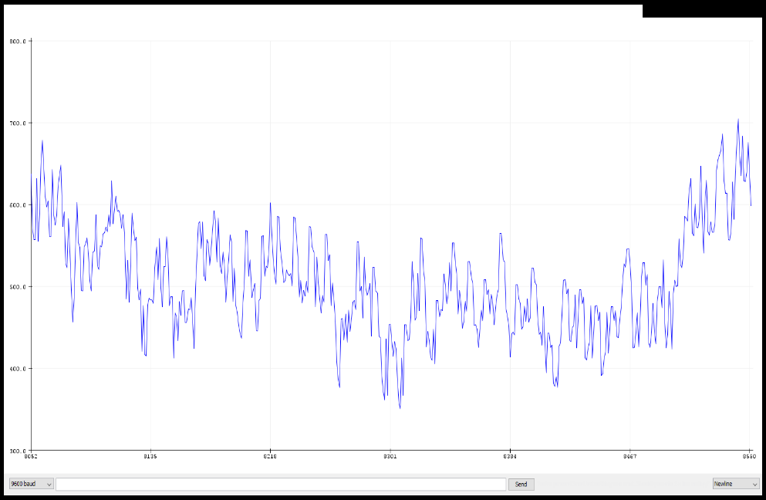
Figure 3.11 Signal with an avg. of 10 readings
I also tried taking the average of more readings. I tried the average of 30 readings. The graph ended up looking something like this. Looking at the graph, we can notice that there is a rising curve (not referring to the spikes, but the larger curve along the graph). This curve indicates that the sensor has detected a heartbeat.
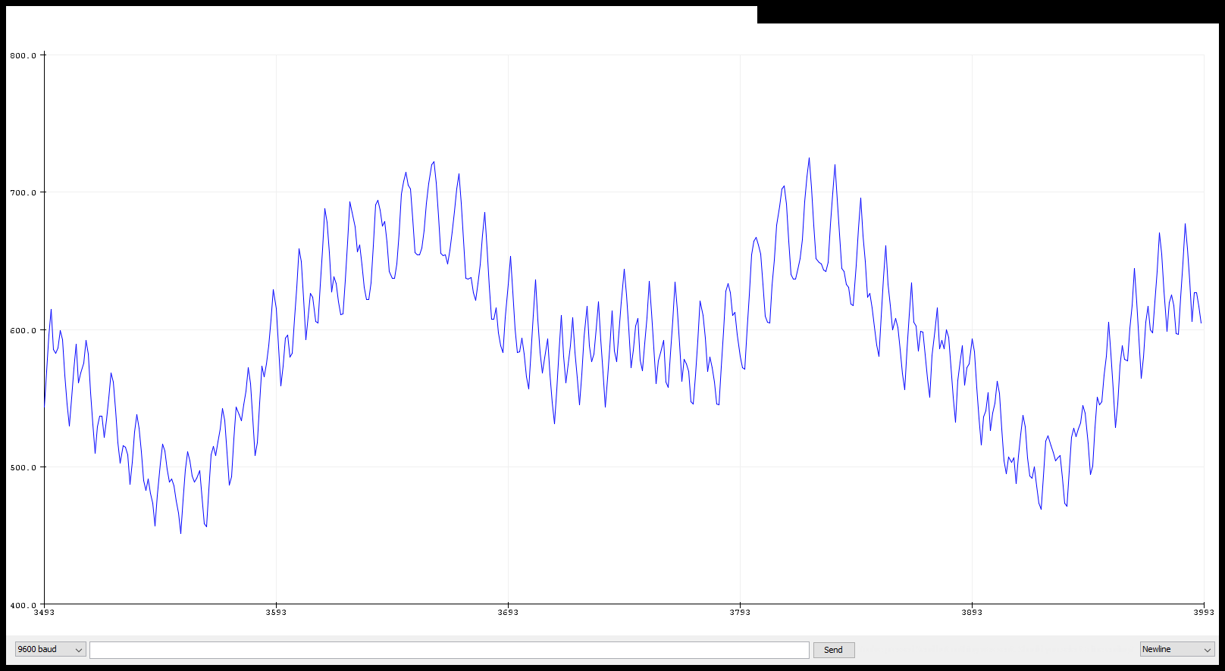
Figure 3.12 avg. of 30 readings. The rising curve indicates a heartbeat

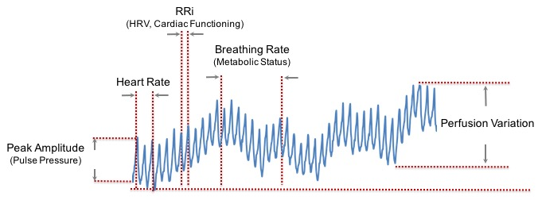
This is the output after using the “averageing” filtering technique. It is still far from perfect, however, it is now easier to understand how the sensor works, because a heartbeat is detectable in the graph.
Figure 3.13 Biometrics we can detect from PPG signals
The image indicates each of the biometrics we can detect from the signal. However, it should be taken into consideration that the output we have gotten is still very rough. With a filtered output we would have been able to produce numerical measurements of various health parameters.

Trying to calculate a numerical value of the heart rate
After trying out the simple filtering method of averageing, I wanted to try and produce an actual numerical value of the Heart Rate, in BPM (beats per minute).
Among the many libraries avaliable in the Arduino IDE software, PulseSensorPlayground had a function that could calculate BPM from the input of the sensor.
However, after trying to get readings multiple times and even trying different algorithms prepared by Arduino libraries, it seems that the values for the heart rate are always too noisy.
The average value for Heart Rate varies from 60 BPM to 100 BPM, but as shown below in the serial monitor of the Arduino Software, the values are a little bit too off.

Figure 3.14 Numerical values from the serial monitor
(The very first reading are “0”, which means that it takes a little time for the sensor to pick up the signal.) 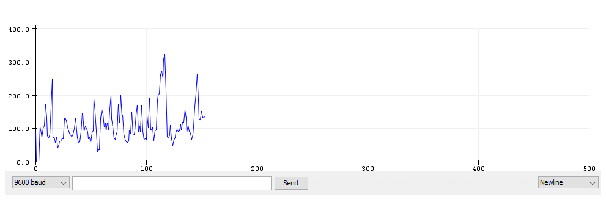
Figure 3.15 Final signal waveform
The final graph ended up looking something like this. While it does not have as many spikes as the other graphs, and the rising curves are peaking, it is still not possible to get an accurate numerical value, so I can conclude that the pulse sensor was only useful for a visual representation.

CONCLUIONS
Health and fitness awareness has continued to grow and expand during the last few years with the new trend of wearable devices. One of the many important biometrics we can measure from these wearable devices is the heart rate. Among many other biological parameters that can be measured through PPG technology, the heart rate can reveal plenty of insight regarding one’s health condition. The number of calories expended in one day can be calculated accurately based on the heart rate. A sleep disorder might also be diagnosed through the analysis of the heart rate. The continuous and non-invasive method of PPG for acquiring the heart rate is ideal for being made into wearable devices.
The affordable technology of pulse sensors makes it very practical for experiments and research. However, good optomechanics are essential in order for the PPG sensor to provide an accurate reading, which is hard to achieve because of how fragile the sensor is. I would have to say that stabilizing the sensor has been the most tiring part of this project. However, this should not take away from the fact that PPG sensors are very convenient and can be made into efficient and inclusive devices that can provide a lot of biometric data, as long as we are doing the right engineering.

REFERENCES
(n.d.). Retrieved from LastMinuteEngineers: https://lastminuteengineers.com/pulse-sensor-arduino-tutorial/
Alkhoury1, L. (2020, june 17). Retrieved from SpringerLink: https://link.springer.com/article/10.1007/s10877-020-00539-2
Ha, J. (2018, 2 April). Retrieved from https://www.hackster.io/Johan_Ha/from-ky-039-to-heart-rate-0abfca
Jaafari, S. (2014). Retrieved from San Jose State University Scholar Works: https://scholarworks.sjsu.edu/etd_theses/4420/
Jiří Přibil *, A. P. (2020, november 14). Retrieved from Research Gate: https://www.researchgate.net/publication/347589318_Comparative_Measurement_of_the_PPG_Signal_on_Different_Human_Body_Positions_by_Sensors_Working_in_Reflexive_and_Transmission_Modes#pf2
Last Name, F. M. (Year). Article Title. Journal Title, Pages From - To.
Last Name, F. M. (Year). Book Title. City Name: Publisher Name.
Madhan Mohan P., N. V. (2017, December 1). Retrieved from IET Research: https://ietresearch.onlinelibrary.wiley.com/doi/10.1049/iet-spr.2016.0455
Malak Abdullah Almarshal, M. S.-A. (2022, March 16). Retrieved from MDPI: https://www.mdpi.com/2227-9032/10/3/547/htm#overview
Optical Heart Rate Monitoring: What You Need to Know. (n.d.). Retrieved from Valencell: https://valencell.com/blog/optical-heart-rate-monitoring-what-you-need-to-know/
Photoplethysmography Sensors. (n.d.). Retrieved from Scholarly Community Encyclopedia: https://encyclopedia.pub/entry/9068
Reference module in biomedical sciences. (2021). Retrieved from ScienceDirect: https://www.sciencedirect.com/topics/medicine-and-dentistry/photoelectric-plethysmography
Wenxi Gao, M. E. (2015, october 24). Retrieved from The anestheseology annual meeting: http://www.asaabstracts.com/strands/asaabstracts/abstract.htm?year=2015&index=12&absnum=2801

APPENDIX A

ARDUINO CODE WITH JUST AVERAGEING FILTER

#define samp_siz 50

int sensorPin = 0;
void setup() {
Serial.begin(9600);
}
void loop ()
{

float reads[samp_siz];
long int ptr;
PulseSensorPlayground last;
float reader;
float sum;
for (int i = 0; i < samp_siz; i++)
reads[i] = 0;

sum = 0;
ptr = 0;

while (1) {

reader = analogRead (sensorPin); // read the sensor
sum -= reads[ptr]; // subtract the oldest reading from sum
sum += reader; // add the newest reading to the sum
reads[ptr] = reader; // save the newest reading in the array
last = float(sum) / samp_siz; // calculate the average now
ptr++; // update the index for the array, have
ptr %= samp_siz; // it restart at 0 when needed

Serial.print(last);
Serial.print('\n');

}

}

APPENDIX B

ARDUINO CODE FOR THE FINAL WAVEFORM
#define samp_siz 4
#define rise_threshold 4

// Pulse Monitor Test Script
int sensorPin = 0;

void setup() {
Serial.begin(9600);
}

void loop ()
{
float reads[samp_siz], sum;
long int now, ptr;
float last, reader, start;
float first, second, third, before, print_value;
bool rising;
int rise_count;
int n;
long int last_beat;

for (int i = 0; i < samp_siz; i++)
reads[i] = 0;
sum = 0;
ptr = 0;

while(1)
{
// calculate an average of the sensor
// during a 20 ms period (this will eliminate
// the 50 Hz noise caused by electric light
n = 0;
start = millis();
reader = 0.;
do
{
reader += analogRead (sensorPin);
n++;
now = millis();
}
while (now < start + 20);
reader /= n; // we got an average

// Add the newest measurement to an array
// and subtract the oldest measurement from the array
// to maintain a sum of last measurements
sum -= reads[ptr];
sum += reader;
reads[ptr] = reader;
last = sum / samp_siz;
// now last holds the average of the values in the array
// check for a rising curve (= a heart beat)
if (last > before)
{
rise_count++;
if (!rising && rise_count > rise_threshold)
{
// Ok, we have detected a rising curve, which implies a heartbeat.
// Record the time since last beat, keep track of the two previous
// times (first, second, third) to get a weighed average.
// The rising flag prevents us from detecting the same rise more than once.
rising = true;
first = millis() - last_beat;
last_beat = millis();

// Calculate the weighed average of heartbeat rate
// according to the three last beats
print_value = 60000. / (0.4 * first + 0.3 * second + 0.3 * third);

Serial.print(print_value);
Serial.print('\n');

third = second;
second = first;

}
}
else
{
// Ok, the curve is falling
rising = false;
rise_count = 0;
}
before = last;

ptr++;
ptr %= samp_siz;

}
}

